Adams Jeffco Hazmat Response

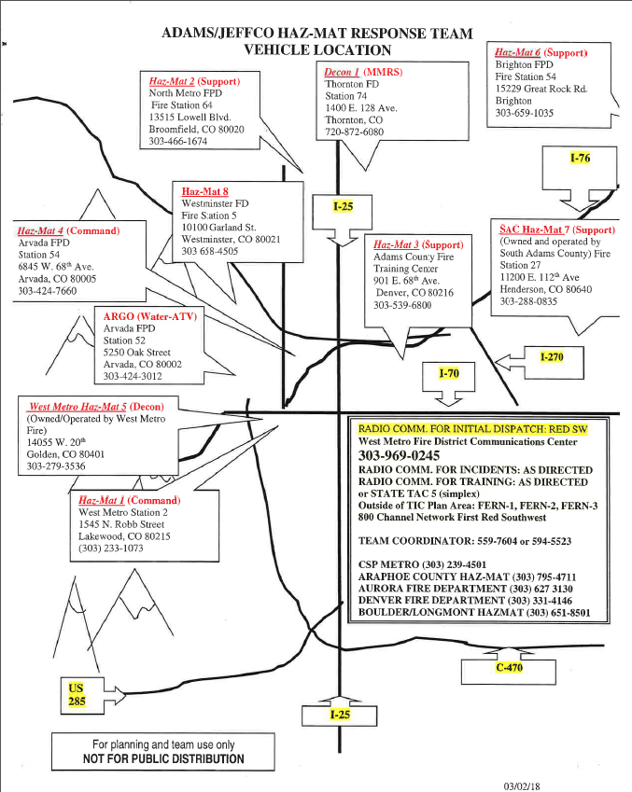
West Metro
Hazmat 1 • 1545 N. Robb Street, Lakewood CO, 80215 • 303-233-1073

Apparatus Capabilities Summary
Entry & PPE | PAPR, SCBA, Level A Comms and Radios, Repeater, Level A Suits, Chlorine A,B,C, Sampling, Entry Link, Weather Station, Decon, Metal Lobster Bucket, Entry-Link HM 360
Radiation | Ultraradiac, Ludlum 14C, BNC SAM 940 Radio-isotope Identifier
Air Monitoring | MultiRae Pro
Detection & Identification | Halogen Leak Detector, ChemPro 100, Ahura, HazMat 360, RAMP, Sampling Supplies, pH Paper, KI Paper, F paper, Protein Test Kit, Ultraradiac, Temp Gun, FLIR Camera, Wood Dowel for papers
Research | Printer, Computers
Decon | Hazmat 5 Decon located at 14055 W. 20th St, Golden CO 80215
Other | Mercury Spill Kit, Calibration Gases

Contact Information

Station 2 Phone | 303-233-1073
Station 5 Phone | 303-279-3536
Dispatch | 303-969-0245

Number of Techs | 44
Number of JeffCo Team Leaders | 9

Name | Station | Shift
Lt. Dustin Horn | 2 | A
Captain Sean Jewell | 2 | A
Lt. David P. Mann | 5 | A
Thomas Biery | 2 | B
Lt. Chad Stodden | 2 | B
Captain Kevin Reichenback | 5 | B
Lt. Mike Frainier | 5 | C
lt. Aaron Johnson | 2 | C
Lt. Matthew Boma | 2 | C

Thornton Fire Department
Decon 1 • 1400 E 128th Ave Thornton CO 80241 • 303-233-1073

Apparatus Capabilities Summary
Entry & PPE | PPE for Decon, undress kits for contaminated, 6 Level Suits, 15 PAPR with 50 cap 1 Canisters
Radiation
Air Monitoring
Detection & Identification
Research
Decon | Mass Decon, 2 large tents, water heaters, 2 generators, lights and heaters for tents, small 2 tub responder decon
Other | Shelter, heat, lighting for long duration events

Contact Information

BC Cell | 303-970-3113
Capt. Anderson | 303-906-7230
Perry Otero | 303-887-8036
Station 4 | 720-872-6170

Number of Techs | 10
Number of JeffCo Team Leaders | 3

Name | Shift
Heather Weissinger | A
Perry Otero | C
Captain Ernie Anderson | C

North Metro Fire Rescue District
Hazmat 2 Support • 13975 S 96th St. Broomfield CO 80020 • 303-466-1674

Apparatus Capabilities Summary
Entry & PPE | 6 Level A suits, 6 Scott 60 minute cylinders
Radiation
Air Monitoring | Basic equipment,
Detection & Identification
Research
Decon | 1 standard, two basin decon station (Kiddie pools, hoses, buckets, brushes, water wyes, Simple Green)
Other | 95 gallon overpack drum, absorbent booms

Contact Information

Battalion 61 | 303-210-4300

Number of Techs | 15
Number of JeffCo Team Leaders | 6

Name | Shift
Eng Richard Schermerhorn | A
FF Todd Field | A
Lt Brian Mills | B
FF/P Matt Gintzler | B
Eng John Cook | C
Eng Mike Dawson | C

Adams County Fire
Hazmat 3 • 901 E 68th Ave Denver CO 80216 • 303-5396800

Apparatus Capabilities Summary
Entry & PPE | Level A Suits of all sizes, 6 SCBA 1 hour cylinders with no PASS device
Radiation
Air Monitoring
Detection & Identification
Research
Decon | Decon setup, walker and kiddy pools, hoses
Other | Booms, absorption pads, absorbent, overpack drums, scene lighting and generator, Megger and grounding/bonding equipment

Contact Information

Coordinator | 303-870-4371
BC Cell | 303-956-3004

Number of Techs | 18
Number of JeffCo Team Leaders | 6

Name | Shift
Tyler Criswell  303-870-4371 | A
Matt Urling  303-885-6049 | A
Cody Grove  303-332-3784 | B
Mike Eason  720-810-6041 | B
Mike Tavalez  303-217-0661 | C
Joe Nichol  303-929-0640 | C

Arvada Fire
Hazmat 4 • 6845 W. 68th Ave, Arvada CO 8005 • 303-424-7660 •

Apparatus Capabilities Summary
Entry & PPE
Radiation | Radiation Meters
Air Monitoring
Detection & Identification | Hazmat ID, Ahura, Isotope Identifier, MultiRae, ChemPro 100i (gas detection), Rae Pbb Meter, M256 Kits, Freon Detector, A-B&C Kits (+ Hydrogen Sulfide Gaskets)
Research | Computer, Research Books,
Decon | Merlin Foam Unit (Foam Decon)
Other | Evidence Collection Kits, Weather Station, HazClass Kit Limited Booms, Non-Sparking Tools,

Contact Information

Station Phone | 303-424-7660
Cell Phone | 303-994-3424

Number of Techs | 45
Number of JeffCo Team Leaders | 12

Name | Shift
Lt. Scott Antill | A
Gabe Katz | A
Joe Chinburg | A
Bryan Attardi | A
Capt. Jamie Denison | B
Todd Sassen | B
Phil Collier | B
Bryce Segovia | B
Lt. Brendon Doughtry | C
Seth Smith | C
BC John Simpson | C
Jake Orr | C

Brighton Fire Rescue District
Hazmat 6 Support • 15229 Great Rock Rd, Brighton CO 80603 • 303-659-1035

Apparatus Capabilities Summary
Entry & PPE | Level A Suits, 6 Scott 60 minute bottles
Radiation
Air Monitoring | 5 Gas
Detection & Identification | Rad Detector
Research
Decon | Decon
Other | Damming and diking. hand tools, booms, absorbent pads

Contact Information

Number of Techs | 18
Number of JeffCo Team Leaders | 1

Name | Shift
Lt. Brad Cogburn  303-888-3181 | C

Westminster Fire
Hazmat 8 • 10100 Garland St. Westminster, CO 80021 • 303-658-4505

Apparatus Capabilities Summary
Entry & PPE | Tyvek Suits, 2 SCBA, HazCad, rubber boots and gloves
Radiation
Air Monitoring
Detection & Identification
Research
Decon
Other | No first in capabilities. Room for 2 personnel in truck

Contact Information

Station 1 Phone | 303-658-4501
Station 5 Phone | 303-658-4505

Number of Techs | 12
Number of JeffCo Team Leaders | 3

Name | Station | Shift
Jim Gagliano  303-901-4727 | 1 | A
Devon Weadon  303-921-1544 | 1 | B
Eric Anderson  303-619-8183 | 2 | C

South Adams County Fire Department
Hammer 27 • 11200 E 112th Ave Henderson, CO 80640 • 303-227-7763

Apparatus Capabilities Summary
Entry & PPE | Various sizes Level B Suits, 8 level A suits in various sizes, 6 Scott 1 hour bottles, 6 extra bottles in storage, 2 bottle air cart
Radiation
Air Monitoring
Detection & Identification | Multiple meters, small incident decon, technical and emergency decon
Research | Laptop, printer, and desk.
Decon
Other | Multiple storage cabinets and full person walk through. Radio coms through ADCOM. Plugging operations, A/B/C Railcar kits, 2 overpack drums, absorbent pads, booms and floor dry. Brooms and shovels.

Contact Information

Station 2 Phone | 303-233-1073
Station 5 Phone | 303-279-3536
ADCOM | 303-969-0245

Number of Techs | 15
Number of JeffCo Team Leaders | 3

Name | Shift
Lt. Alden Foote | A
Lt. Dean Vitale | B
BC Bobby Noel | B
Lt Nate Romero | C

Boulder County Hazmat Authority
Longmont Fire, Boulder Fire, Lafayette Fire, Louisville Fire, Mnt View Fire, Boulder Rural Fire
161 Perry Ln, Dacono CO 80514 • Foam Truck

Apparatus Capabilities Summary
Entry & PPE | SCBA, Level A&B suits
Radiation
Air Monitoring | Perimeter monitoring, Multi-Rae
Detection & Identification | Sampling, wet chemistry
Research
Decon | Basic Decon
Other | 500 gallons of foam, Overpacks, Booms

Contact Information

Longmont | 303-774-4625
Boulder Fire | 303-441-3648
Mnt View | 303-772-0710

Number of Techs | 44
Number of JeffCo Team Leaders | 9

Name | Dept.
Stew Visser | Longmont
Kevin Kern | Boulder
Ed Seibert | Mnt View
Chris Wetzel | Longmont
Robert O’Donnel | Boulder Rural

